REASONS TO BE HOPEFUL – HOW THE GAP IN LIFE EXPECTANCY BETWEEN ENGLISH REGIONS WAS NARROWED
Nicholas Hicks and Jon Bright
The purpose of this note is to draw attention to a significant success in health policy.
We are bringing evidence of it to politicians, health policy advisors, think tanks and the media because we suspect it has been largely forgotten.
It shows that Government really can make a difference to a problem generally regarded as intractable.

What happened?
During the 2000s, a government strategy to tackle health inequalities in England led to a reduction in geographical differences in life expectancy. Furthermore, this success reversed a previously increasing trend. Much of this narrowing was due to reductions in mortality and in inequalities in mortality due to coronary heart disease.
The chart below shows an overall reduction in coronary heart disease mortality and a reduction of nearly 20% (19.07%) in the gap between the national average and the poorest areas . 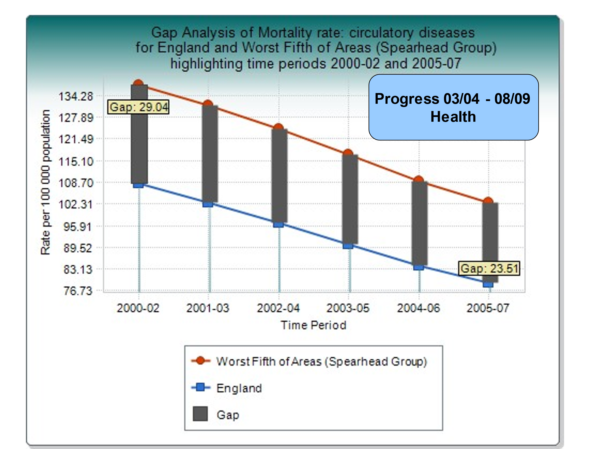
This is the only period in the last 50 years when inequalities in all-cause mortality between rich and poor have narrowed. It was a considerable achievement and an historic result.

What was the impact in terms of lives extended?
In practical terms, this policy meant that many millions of people lived longer and healthier lives. Some of the benefit was probably due to changes in smoking behaviour and risk factor management (e.g., blood pressure, cholesterol) provided by the NHS. In 2000, 38% of the adult population smoked and smoking was twice as common amongst those on low incomes than those who were more affluent. Today, only about 13% of the adult population smoke, the lowest since records began.
But this achievement was not down to health and health care policy alone. Importantly, it was also attributable to coordinated action across Government to tackle inequalities more generally, as the core determinants of health lie outside the health sector.

What were the policy drivers?
This work started with (a) the NHS Plan (2000) which committed the Government to publishing national inequality targets, and (b) the Department of Health’s 2000 Framework for Coronary Heart Disease.

These led to a government commitment to reduce health inequalities in a Spending Review the following year which set targets and made available the necessary investment. These targets were then translated into cross departmental delivery plans (Public Service Agreements).

These Public Service Agreements required central government Departments to do better in those parts of the country where outcomes were poorest, not only in health but also for low income, family functioning, education, employment, and crime.
These wider issues – the core determinants of health - are known to have a substantial influence on people’s health. Targeted reforms (see below) created a context in which health-specific interventions were more likely to succeed.
This broader cross-government work to reduce regional inequalities was coordinated by the Neighbourhood Renewal Unit, located in the then Department of Communities and Local Government.
Writing in 2017, researchers concluded that ‘future approaches should learn from this experience”. They expressed concern that current policies (in 2017) were probably reversing this achievement of the previous decade (Barr, B. Higgerson, J. and Whitemead, M (2017) op cit).
What did all this mean in practice for people living in poorer regions?
Health specific interventions included smoking cessation clinics; a major effort to improve the distribution of GPs - many disadvantaged areas had no GP service and people used hospital A&E departments; improved resource allocation to disadvantaged areas; national guidance on best evidence-based practice (eg The National Service Framework for Coronary Heart Disease and the creation of NICE); and improved access to mental health services.

Reforms that also addressed the wider determinants of health included action on housing (the Decent Homes Standard); increasing household income (the Minimum Wage, Tax Credits); education (to improve attainment); adult skills & employment; reducing the number of young people not in education, employment and training; teenage pregnancy prevention; and early years - Sure Start, school readiness and family support.
This approach is consistent with Prof Michael Marmot’s conclusions subsequently reached in his 2010 report, 'Fair Society, Healthy Lives'. He noted that reducing health inequalities would require action on six policy objectives:
- Give every child the best start in life.
- Enable all children, young people and adults to maximise their capabilities and have control over their lives.
- Create fair employment and good work for all.
- Ensure healthy standard of living for all.
- Create and develop healthy and sustainable places and communities.
- Strengthen the role and impact of ill-health prevention.

Was this achievement supported by other research?
Holroyd et al conducted a systematic review⁵ of the effectiveness of the health inequalities strategy in England between 1999 and 2010 (see Annex for a fuller discussion).

Its design Three databases and ‘grey literature’ were searched for articles that reported on changes in health inequalities in England between 1999 – 2021. Data were extracted from eligible studies, and risk of bias was assessed using the Risk of Bias in Non-randomized Studies of Interventions tool.

Its findings. The search strategy identified 10,311 unique studies, which were screened. 42 were reviewed in full text and 11 were included in the final review.
Six studies contained data on inequalities of life expectancy or mortality, four on disease-specific mortality, three on infant mortality and three on morbidities.

The highest quality publications using the most accurate data and most appropriate measures find that absolute and relative inequalities decreased throughout the strategy period for both measures (all-cause mortality and infant mortality).
Three studies found a narrowing of inequalities in all-cause mortality and that absolute inequalities in mortality due to cancer and cardiovascular disease also decreased.
Its conclusions. With respect to its aims, the strategy was broadly successful. Policymakers should take courage that progress on health inequalities is achievable with long-term, multiagency, cross-government action.

What lessons should we draw?
There are five main lessons to draw from this evidence:
1. When Government takes a coordinated approach to a problem – and sticks with it over time - the results can be impressive. Improvements in outcomes – even at scale - are usually the result numerous small interventions rather than one or two silver bullets. Note: There are similar graphs from the same period reflecting a narrowing of regional inequality in educational attainment and crime.
2. Health is a good proxy for Levelling Up. Narrowing the gap in mortality and morbidity is a good proxy for ‘levelling up’ more widely. Health inequalities are to an important extent a consequence of poverty, poor education and skills, access to employment, and insecure and poor-quality housing.
3. Leadership and persistence are essential. A ‘whole of government’ approach requires good cross departmental working over time, engagement with local government and public health services, and leadership from the Prime Minister.
4. Tackling the nation’s problems needs longer term policy making so successful approaches don’t fizzle out whenever there is a change of Government. In this case, benefits achieved up to 2010 may have been lost by 2017. Maintaining progress requires cross-party, long-term collaboration.
5. This approach worked by influencing how mainstream budgets were used via better targeting and evidence-based interventions, rather than relying on special ring-fenced funding.

The big health challenges today are obesity, diabetes and related conditions. Again, poorer populations are much more affected.
Will today’s politicians rise to the occasion?

Nicholas Hicks and Jon Bright

October 2023
The authors

Dr Nicholas Hicks BM BCh FRCP FRCGP FFPH is an Honorary Senior Research Fellow, Nuffield Department of Primary Health Care Sciences at the University of Oxford. He is also an Associate Fellow, Green Templeton College, University of Oxford. He was seconded to the Department of Health Strategy Unit and helped draft the inequalities chapter of the NHS Plan in July 2000.

Jon Bright MA, BA is a former Senior Civil Servant who worked in the Cabinet Office and Department of Communities and Local Government between 1998 and 2014.

ANNEX
Further comments on the research by Dr Nicholas Hicks
Holroyd et al’s systematic review of the effectiveness of the English health inequalities strategy found that ambitious national targets set in 2001 for reducing inequalities in infant mortality and life expectation by 2010 were largely met.
This is the only period in the last 50 years when inequalities in mortality between rich and poor have narrowed in England.
If policy makers are to maximise learning from this achievement, it’s important that they have a clear understanding of the interventions undertaken. The factors determining the distribution of health are complex and multifactorial.
In any complex system, a strategy aimed at influencing outcomes needs to be as much about the approach to intervention as about the content of the policies (1). The papers Holroyd et al cite are incomplete descriptions of the strategy as they omit the key elements that were central to resourcing, cross-sectoral incentivisation, metric generation and harnessing of power.
Key elements of the intervention strategy included:
• The NHS Plan (2) that set out Government's commitment to the publication of national inequalities targets. The targets were published in February 2001. The detailed rational for the setting and construction of those targets was explained in a technical paper (3).
Without knowing the exact impact of any one action, the architects of the strategy believed that if inequalities in mortality were to be reduced, it was essential to address inequalities in the broad determinants of health. It was also believed that the cumulative impact on health and wellbeing of multiple cross sectoral actions would be greater than the simple sum of the impact of individual actions.
• The inclusion of the national inequalities targets as central elements of the 2002 Spending Review. The Spending Review is the process by which multi-year budgets are set and targets agreed for all central Government departments. The government was explicit that their approach to tackling inequalities would be multi-sectoral: “The Government is committed to narrowing the gap between the poorest neighbourhoods and the rest of the country…The 2002 Spending Review takes this strategy further ..... This puts in place deprivation-related targets for education, employment, crime, health, housing, enterprise, road accidents and regional growth."
The consequence of putting inequalities at the heart of the spending review meant that spending departments didn’t get their money unless and until they agreed targets, developed plans and funded actions intended to address inequalities.
The use of Public Service Agreements incorporating health and other inequalities targets for the performance management of all Whitehall spending departments with additional oversight from the Prime Minister's Delivery Unit. This created strong and aligned incentives across the public sector heavily focussed on reducing inequalities including health inequalities.
I believe that if the actions summarised above were at the core of funding, incentivising and securing long term coordinated, multi-sectoral action across the public sector, intractable problems can be tackled.
But publishing strategies without considering the means for their delivery achieves very little. If we are to maximise our learning from the health inequalities strategy, we need to pay attention to the ‘how’ as well the ‘what’.

References
1. Meadows D. Leverage points: places to intervene in a system.
2. NHS Plan. A plan for investment; a plan for reform. Department of Health (2000): 106-7 https://webarchive.nationalarchives.gov.uk/ukgwa/20050720205711/http://w...
3. Health inequalities – national targets on infant mortality and life expectancy – technical briefing . Department of Health March 2002 https://webarchive.nationalarchives.gov.uk/ukgwa/20130107105354/http://w...
4. Spending Reivew 2002: Public Service Agreements., HM Treasury 2002 para 1.12 https://webarchive.nationalarchives.gov.uk/ukgwa/20071204183446/http://w...
Show Less
5. Holdroyd I, Vodden A, Srinivasan A, Kuhn I, Bambra C, Ford JA. Systematic review of the effectiveness of the health inequalities strategy in England between 1999 and 2010. BMJ Open. 2022 Sep 9;12(9):e063137. doi: 10.1136/bmjopen-2022-063137. PMID: 36134765; PMCID: PMC9472114.

Conflict of Interest: The author was seconded from the NHS to the Secretary of State's Strategy Unit, Department of Health and was involved with the drafting of the inequalities chapter of the NHS Plan (July 2000).

Barr. B, Higgerson. J and Whitehead. M, (2017) Investigating the impact of the English health inequalities strategy: time trend analysis, British Medical Journal (BMJ).
Department for Health and Social Care (2000) National Service Framework for Coronary Heart Disease Prevention; and National Health Service (2005) Leading the Way- Progress Report 2005, Coronary Heart Disease National Service Framework.

